* **Sudo yum list | grep java-1.8**

By the above command we can filter the java packages from yum repository

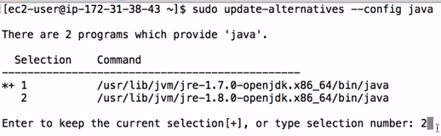

* If we have two versions of java and want to choose one as default, we can do as above
* We need at least 4 GB RAM server to do this